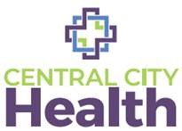
Quality Care for Everyone

We Offer a Sliding Fee Discount Program
• Discounts are available based on household size and income
• All patients are encouraged to apply—insured, uninsured, and underinsured

No Patient Is Ever Denied Care
• Services are not denied due to inability to pay
• We are committed to providing accessible, affordable care for our community

How to Apply
• Ask the front desk about the Sliding Fee Application
• Our staff will help you complete the process

Have Questions?
Call us at: 313-831-3160
Visit: Centralcityhealth.com

